Full Access & Coordinated Transportation
2013-2018 Business Plan Update

Adopted by the Board of Directors
1/18/2012

Table of Contents

Chapter 1: FACT- an Overview p.5-7

1.1 Background p.5

1.2 Mission & Vision p.5

1.3 Governance p.5

Chapter 2: Specialized Transportation Needs & Response p.8-10

2.1 Regional Transportation Needs p.8

2.2 Existing Transportation Services p.8

2.3 Regional Transit “Gaps” p.10

2.4 Meeting Regional Needs p.10

Chapter 3: FACT Services – Current p.11-13

3.1 Transportation Provider Database & Website Mgt. p.11

3.2 Telephone Referrals p.11

3.3 Outreach and Assistance to Providers p.11

3.4 Donated and Auctioned FACT Vehicles p.12

3.5 RideFACT p.12

3.6 Escondido, Rancho Bernardo, Poway Senior Trans. p.12
3.7 FACT and STRIDE Website Integration and Update p.13

Chapter 4: FACT Services – Proposed p.14-19

4.1 Proposed Short Term Services (1-2 Years) p.14

4.1.1 Software Based Brokering and Mobility Management p.14

4.1.2 MedRIDE p.14

4.1.3 MedAccessRIDE p.15

4.1.4 Enhanced Customer Assistance and Outreach p.15

4.1.5 WorkRIDE p.15

4.1.6 Technical Assistance Workshops p.16

4.1.7 Contracted Mobility Management & Transportation

Services

4.1.8 5310 Vehicles p.16
4.1.9 Mobility Management for Diverse Seniors p.17

4.2 Proposed Long Term Services (3-5 Years) p.17

4.2.1 Medical Transportation Coordination p.17

4.2.2 MEDICAID Transportation Brokerage p.17

4.2.3 Expansion of MedRIDE and MedAccessRIDE p.18

4.3 Potential Programs Currently Unfunded p.18
4.3.1 Mobility Management Pilot Program p.18
4.3.2 Maintenance Coordination p.18
4.3.3 Volunteer Driver Program Resource Allocation p.18
4.3.4 Older Driver Wellness Program p.19
4.3.5 DMV Guaranteed Ride Home Program p.19

4.3.6 Homeless Transportation Program p.19
4.3.7 Brokerage Software Program p.19

Chapter 5: Funding p.20-22

5.1 Current Funding Sources p.20

5.2 Potential Short-Term Funding Sources p.21
5.2.1 Agency Contracts
5.2.2 Extended Mobility Management Services p.21
5.2.3 NEMT (Non- Emergency Medical Transportation)
Pilot Funding p.21
5.2.4 Small Grant Programs and Awards p.22

5.3 Potential Long-Term Funding Sources p.22

5.3.1 Quality of Life Initiative p.22

5.3.2 Regional Transportation Plan 2050 p.22

5.3.3 Hwy 5 Mitigation Measures p.22

Appendix p.23-29

1 CTSA Work Plan p.23

2 Service Providers p.27

Executive Summary
FACT updates its Business Plan annually to maintain the plan as a current reference, as well as to comply with the requirement of the CTSA contract with SANDAG. This is the second update to the original Business Plan adopted in 2009. The 2009 Business Plan was a comprehensive review of FACT’s purpose, the business environment, the community and stakeholders. The plan identified a number of potential services and collaborations that would contribute towards FACT’s previous mission of meeting as many unmet needs for specialized transportation as possible. Due to the timing, the project proposals introduced in the original plan were presented in concept, without identified budgets, resources and/or service parameters.
The 2012-2017 Business Plan Update was an “action plan” that focused on current transportation needs and current FACT projects and services. The plan included an overview of FACT as an organization, a review of the transportation needs in San Diego and a plan to respond to the needs based on priorities established by regional consensus and the availability of funds. The transportation needs described in the plan were derived from the San Diego Association of Governments’ (SANDAG) 2010-2014 Coordinated Plan, which analyzes transportation needs through surveys, data, and stakeholder input.
The plan addressed the current status of all the service and collaborative proposals. It prioritizes projects by readiness with respect to funding as well as other practical considerations, including readiness of partnering agencies to engage in the projects. Projects were classified as “short term” or “long term” priorities or “potential new programs currently unfunded”. This Plan Update also reviews all FACT revenues and funding sources as well as makes recommendations for changes to the way FACT is funded in order to provide more certainty in the future and the ability to plan for longer terms.
The 2013-2018 Business Plan Update includes updates to the FACT Mission, staff, Board members, projects/proposals, some services and funding. All current and proposed services were reviewed to fit the new FACT Mission adopted by the Board of Directors on May 18th, 2011. Significant updates in the proposed 2013-2018 Business Plan Update include:
Section 1.2—FACT Mission Statement
Section 1.3— Updated Board members and officers
Section 1.3—FACT filled two positions—the Mobility Coordinator and Administrative Assistant
Section 3.5—RideFACT was discontinued as of October 2011, and the remaining Transnet funds are being used to implement a brokered senior transportation service within Escondido, Rancho Bernardo, and Poway; service will begin in January 2012.
Section 3.7—The FACT and STRIDE websites have merged and FACT no longer refers to the transportation database as “STRIDE”. The new FACT website will be available in January.
Section 4.1.1—FACT is reviewing software to assist with reservations, scheduling, and dispatching of trips. FACT plans to procure software in June 2012.
Section 4.1.5—Updated the WorkRIDE program proposal to be consistent with JARC application that was submitted in December of 2011. The earlier WorkRIDE application (submitted in 2010) was not funded.
Section 4.1.8— FACT was awarded 7 vehicles through the Section 5310 program to provide brokered transportation to seniors and persons with disabilities.

Chapter 1: FACT- An Overview

1.1 Background
FACT was started as an informal organization in 2005 by community activists. The goal was to develop a coordinated transportation system for San Diego County. FACT was incorporated as a non-profit public benefit corporation in 2006, and designated the Consolidated Transportation Service Agency (CTSA) for San Diego County by the SANDAG. The CTSA’s are mandated by California State law to coordinate and consolidate human services transportation. FACTs CTSA designation covers San Diego County.

SANDAG contracted with FACT to designate it as CTSA via a competitive procurement process. The contract is renewed annually for an unspecified term. The CTSA designation authorizes FACT to claim TDA 4.5 funds from SANDAG and gives FACT the potential to be recognized as a direct grantee of the United States Department of Transportation (USDOT).

CTSA activities include mobility management and brokerage of information and transportation services in order to maximize the service capacity and utilization. The Work Plan included in the contract requires FACT to fulfill specific duties (Appendix 1.1a).

In addition to transportation services coordination, FACT provides transportation in communities where other local and regional services are not available. While FACT’s services are focused on seniors and persons with disabilities, the CTSA mandate includes services for low income individuals, youth, veterans, as well as other transportation disadvantaged populations.

1.2 Mission & Vision
FACT’s Mission is to assist seniors, persons with disabilities, and social service recipients in San Diego County to meet their transportation needs.
We will:
- Coordinate resources and services with public and private stakeholders
- Act as mobility manager to provide information on transportation resources available
- Advocate on behalf of the people we serve
- Educate stakeholders about transportation needs
- Obtain and secure funding
- Procure and administer contracts for specialized transportation services to address unmet needs

1.3 Governance
FACT is governed by a Board of Directors that currently has 7 members; Board members are appointed by the Board except one member who is a representative from the Transportation Committee – a sub-committee of the SANDAG Board of Directors.
The FACT Board has appointed 2 advisory committees - the Council on Access and Mobility (CAM) and the Technical Advisory Committee (TAC). The FACT Executive Director, TAC and CAM report to the Board.

Figure 1-1 FACT Organization Chart

Board of Directors:
- Dave Roberts — Board Chair — Councilmember, City of Solana Beach, Member of SANDAG Transportation Committee
- Bob Campbell — Board Vice Chair — former Councilmember, City of Vista
- Susan Hafner — Board Treasurer — Principal, Multimodal Solutions
- Teresa Barth — Board Secretary — Councilmember, City of Encinitas
- John Aguilera — Councilmember City of Vista
- LaVonna Connelly — Ramona Transportation Action Committee
- Phil Monroe — former Councilmember, City of Coronado

The FACT Board meets once a month, on third Wednesdays, at Encinitas City Hall at 9:00 a.m.

Technical Advisory Committee (TAC):
1. Janelle Carey, MTS
2. Eric Hoch, NCTD
3. Lois Knowlton, Friends of Adult Day Health Care Centers
4. Danielle Kochman, SANDAG
5. Floyd Willis, AIS

TAC participates in Board meetings and meets with staff to advise on special programs or projects.

Council on Access and Mobility (CAM)
CAM has 25 seats, 20 of which are currently occupied by stakeholders. Members include service providers, planning agencies, consultants, community members, and represent a cross section of transportation interests in San Diego County. CAM meets every other month. The meetings are held alternately in North County and San Diego. The Mission is to “Promote coordination of transportation resources and services in San Diego County”.
CAM Membership Structure:
- Regional Agencies and Public Transportation Providers (5)
- Specialized Transportation Providers (5)
- Private Sector Providers and Consultants (5)
- Faith Based Transportation Providers (2)
- Hospital and Medical Transportation Providers (3)
- Tribal Agency (1)
- Rural Transportation Representative (1)
- Open Seats (3)

Staff
FACT is managed by an Executive Director who is responsible for managing FACT’s programs, developing partnerships with other agencies, and overseeing staffing and planning meetings of the FACT Board. There are 4.6 full time equivalent staff at this time, including a Service Development Planner, a full time and a part time Mobility Coordinator, and an Administrative Assistant. There is one vacant position –Accounts/Grants Analyst that will be filled in FY 2012.

Chapter 2: Specialized Transportation Needs & Response

2.1 Regional Transportation Needs
The 2010-2014 Coordinated Plan produced by SANDAG identified unmet transportation needs for urban, suburban and rural areas of San Diego County. The plan evaluated existing transportation services, public, private and social service providers, and prioritized strategies to provide transportation to sensitive population groups including individuals with disabilities, persons with limited means, and seniors. The following is a summary of the transportation needs
- Individuals with Disabilities—There are approximately 300,000 persons with disabilities in San Diego County according to the Census 2010. For persons with disabilities, Medical, Religious, School, Recreation/Leisure and Other trips totaled un-served trip percentages over 30 percent. The data reflects that transportation for persons with disabilities is most lacking for medical and quality of life trips.

- Person with Limited Means—The Coordinated Plan states that there are approximately 170,000 persons living below the 150 percent poverty threshold who presumably need transportation to and from employment destinations. SANDAG has identified dense areas where low income individuals live and work. The data analysis revealed that a quarter of the work related trips were un-served. Medical and recreation/leisure trips were the most underserved.

- Seniors—The aging population in San Diego County is projected to significantly increase 125 percent by year 2030. Transportation to and from medical services (non-emergency) is one of the most important needs among seniors. Survey data revealed Religious and School trips were the most un-served need for seniors (persons over 65).

2.2 Existing Transportation Services
San Diego County has public transportation services that are operated by Metropolitan Transit System (MTS) and North County Transit District (NCTD). MTS serves Central, Eastern, and Southern areas of the county, and NCTD serves North and Northeastern parts of the county. The two agencies together provide fixed-route services, ADA Paratransit, light rail, and two commuter rail services, the Coaster and Sprinter. Private and social service transportation providers also serve seniors, individuals with disabilities and persons with limited means through various programs, including volunteer driver programs, the traditional directly operated van services as well as subsidized taxi services. For a comprehensive list of these programs please refer to the database of approximately 150 transportation programs at www.factsd.org

Figure 2-1 Social Service Transportation Providers

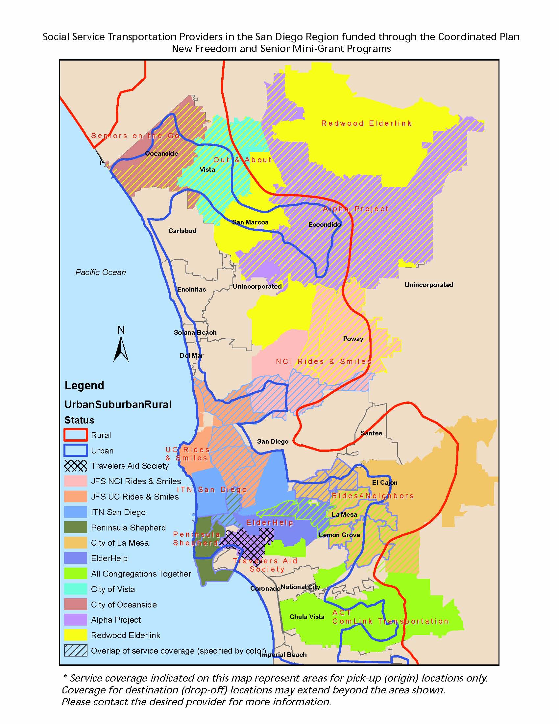

2.3 Regional Transit “Gaps”
The Coordinated Plan outlines regional transit “gaps” for individuals with disabilities, persons with limited means and seniors. These gaps represent geographic areas lacking public, private and social service transit. Some of the gaps represent the following cities/regions:
- Chula Vista
- City Heights
- Miramar
- North Park
- Northeast Oceanside
- City of San Diego
- Escondido
- Imperial Beach
- National City
- Oceanside
- Vista
- Carlsbad
- Encinitas
- El Cajon
- Lakeside

These gap areas have significant impacts on sensitive populations who are often dependent on transit for regional services. The Coordinated Plan states that medical, employment, religious and other destinations are the most underserved for these sensitive populations. For a complete list of the gap areas please refer to Appendix O of the Coordinated Plan.

2.4 Meeting Regional Needs
FACT’s priority is to coordinate with existing transportation providers to serve areas that represent gaps in current services. FACT operates as mobility manager by identifying the needs of potential riders and referring them to an existing, appropriate service. FACT maintains a current database of transportation resources which can be accessed directly via the FACT website (www.factsd.org) or via telephone by calling staff (Mobility Coordinators) who look up the information to provide referrals. The data from callers corroborates and defines the gaps that exist between transportation services.

Chapter 3: FACT Services – Current

3.1 Transportation Provider Database and Website Management
FACT maintains a public, private and social service transportation database (www.factsd.org) of existing programs throughout the County. The database and web based referral system was established in 2001 through New Freedom Funds and is supported by numerous transportation providers. FACT offers online referral service with comprehensive information about specialized transportation providers. The database includes approximately 150 transportation services. These services include public, private, social service and volunteer driver transportation programs (for a list of providers see appendix 3.1a).

The database allows riders to search programs that meet their search criteria, for example programs that service seniors or low income individuals, or certain zip codes. The new FACT website has a trip planner that suggests programs based on the riders’ trip origin and destination and specific needs (wheel chair accessible, ambulatory, non-ambulatory etc). Web hits have increased from approximately 1,500 visits per month to 1,800 hits per month during FY 2012.

FACT is partnering with SANDAG to update the database to ensure the information is accurate. The last update was completed in 2008.

3.2 Telephone Referrals
FACT’s Mobility Coordinator provides toll free telephone referrals that match the appropriate transportation service to the individual needs of the customer. In FY 2012, FACT phone referrals increased from an average of approximately 45 to 90 per month. FACT is looking for funding and opportunities to expand this service to include enhanced customer service and assistance for riders.

3.3 Outreach and Assistance to Providers
As the CTSA, FACT coordinates and collaborates with several transportation providers. To increase coordinated efforts, FACT facilitates the Council on Access and Mobility (CAM), an advisory committee to the FACT Board that meets bi-monthly to discuss transportation issues and coordination efforts. FACT also participates in the San Diego County Volunteer Driver Coalition, Ramona Transportation Action Committee (RTAC), and is a member of the Social Service Transportation Advisory Council (SSTAC). FACT is partnering with Alliance for Regional Solutions (ARS), Aging and Independence Services (AIS), Palomar Pomerado Health (PPH), and Scripps Hospital on several service proposals.

FACT is also partnering with SANDAG for enhanced outreach to service providers. FACT staff will conduct a survey which will be used to gather the following information:
- Provider and program information (days, hours, fares of transportation service)
- Customers served and total trips provided per program
- Interest in coordinating with FACT (grants, programs, services, brokerage, or other programs)

The data will be used to update information on the database and for the Coordinated Plan Update.

3.4 Donated and Auctioned FACT Vehicles
In April 2010, FACT donated 12 accessible minibuses to local nonprofit agencies via lottery. Recipients included City Link Foundation, Green Oaks Ranch Ministries, North County Lifeline, From the Inside Out and two local Boys and Girls Clubs.

In December 2010 and October 2011, FACT auctioned 14 accessible minibuses and vans to local transportation providers. Recipients included City Link Foundation, Sol Transportation, La Mesa Work Center, Bethel Baptist Church and others. The vehicles were sold for $49,100. The proceeds will be used as match towards new grants.

3.5 RideFACT
In October of 2010, FACT implemented RideFACT, a senior transportation service in Ramona. RideFACT was funded by a Transnet Senior Mini-Grant for fiscal years 2009, 2010, and 2011. FACT contracted with Sol Transportation for scheduling, dispatching and transportation.

RideFACT operated 2 days a week, on Tuesdays and Thursdays between 9am and 5pm. Reservations were scheduled a day in advanced to promote ridesharing. Trips within the core area of Ramona (Zone 1) or within San Diego Country Estates (Zone 2) had a $3 one-way fare. Trips between Zone 1 and Zone 2 had a $5 one-way fare. Service was curb-to curb, unless a request for door-to-door service was made at the time of reservation.

An estimated 1,200 one-way trips were budgeted for the first year of service. During the second and third years 2,400 and 3,600 trips were to be provided respectively.

RideFACT was discontinued by a Board vote on August 17th 2011. The last day of service was October 4th, 2011. The service provided approximately 35 trips per month and completed 425 one way passenger trips over 12 months. RideFACT was replaced by a new “Flex” service introduced by NCTD in August of 2011.

3.6 Escondido, Rancho Bernardo, Poway Senior Transportation
In January 2012, FACT implemented a senior transportation service that provides general purpose trips to seniors 60+ living within the Escondido, Rancho Bernardo, Poway service boundary. This is a brokered service in which FACT will provide trips using the most appropriate provider. When a trip request is received, FACT will refer the caller to an existing transportation service. Trips that cannot be appropriately served by an existing transportation provider will be served by one of FACT’s contracted service providers.
This service is funded by the remaining Senior Mini Grant funds used for RideFACT (approximately $113,000 available). FACT will be able to provide 4,525 trips (at an estimated $25/trip) during the 12-month period; approximately 377 one-way passenger trips each month. Service will operate Monday through Friday between 8 a.m. and 6 p.m. Reservations will be accepted through the FACT Call Center on a first come first served basis from 9 a.m. – 3 p.m., Monday – Friday, up to 7 days before the trip. They will be confirmed with the provider and rider on the same day when possible.
Where possible, trips will be grouped in order to utilize vehicle capacity and make the service cost effective.

3.7 FACT and STRIDE Website Integration and Update
During late 2012, FACT worked with a web designing company to redesign the FACT website and integrate the STRIDE database into it. The preliminary design and structure was approved in December 2012. The website is expected to be completed in January of 2012.

The goal is to create a more user friendly, interactive, and accessible FACT website for users with all levels of internet skills. The STRIDE website will be merged with the FACT website to make it easier to find and navigate. This project will be funded by a 2007 New Freedom grant for mobility management services. Upgrades to the database will include:
- Updated database of transportation providers and services
- Improved trip planner
- Interactive service map

FACT has secured additional New Freedom funds for increasing outreach to transportation providers/resources in order to maintain and update the transportation services inventory. The new grant will also allow for new direct services to potential riders, including one on one consulting on transportation services and personalized assistance when needed.

Chapter 4: FACT Services – Proposed

4.1 Proposed Short Term Services (1-2 Years)

4.1.1 Software Based Brokering and Mobility Management
In February 2011, FACT initiated the research for procurement of a software based system for coordinating regional transportation services. The software will allow FACT to share trip requests with service providers, dispatch trips, negotiate trip costs, and report on trips.

FACT has reviewed four software options: RouteMatch, Shah Software, RideScheduler, and Mobilitat. FACT is also working with a California State University San Marcos (CSUSM) student team to research these software systems and recommend the best fitting software to FACT.

The exact scope of the software based mobility management system will be determined in consultations with CAM, TAC and the software vendors. FACT has convened meetings and workshops with stakeholders to facilitate a joint review of the products that are available.

The implementation of a software based system will help FACT operate a brokerage for transportation services in order to serve transportation needs efficiently.

4.1.2 MedRIDE
MedRIDE is a TransNet (Senior Mini Grant) and New Freedom grant funded project which was approved in February 2011 for a two year period. MedRIDE transportation will be contracted out and will serve seniors (over 60) who wish to access medical services (non-emergency) only. Approximately 16,000 one way vehicles trips will be provided over the term of the project.

Trip requests will be reviewed by FACT’s Mobility Management staff who will try to direct the request to an existing transportation system (bus, rail, ADA Paratransit or volunteer driver service); if existing transportation services are not available/appropriate, the request will be forwarded to the contracted service provider for the delivery of the trip. Fares will be comparable to similar social services transportation available in the county.

The proposed service area is the approximate urban/ suburban boundary identified by SANDAG in the Coordinated Plan. The service will begin with this baseline service region, which will be expanded in the second year of service. Service hours will be from 9:00am-5:00pm Monday-Friday. Service will be curb-to-curb and door-to-door with door-through-door service accommodation on a case by case basis. Travel appointments will be made in advance in order to promote ride sharing. Trips will be served on a first come basis; personal care attendants (PCA) will be accommodated free of cost by the service policy and companions will be admitted on a space available basis at the regular fare.

FACT will consult with CAM and TAC prior to establishing the service parameters proposed above. Implementation of the services is planned for mid 2012.

4.1.3 MedAccessRIDE
MedAccessRIDE is funded primarily by a New Freedom and Transnet (Senior Mini Grant) grant approved in February 2011 for one year. MedAccessRIDE transportation will be provided through a public private partnership involving FACT and Sol Transportation. FACT will procure one accessible minivan which will be leased to Sol for providing transportation to individuals with disabilities who wish to access medical services (non-emergency) only. Approximately 1,300 one way vehicles trips will be provided over the term of the project.

Trip requests will be reviewed by FACT’s Mobility Management staff who will direct the request to an existing transportation system (bus, rail, ADA Paratransit or volunteer driver service); if existing transportation services are not available/appropriate, the request will be forwarded to Sol Transportation for the delivery of the trip. Fares will be comparable to similar social services transportation available in the county.

The proposed service area is the North County and North County inland urban/suburban boundary identified by SANDAG in the Coordinated Plan. Service hours will be from 9:00am-5:00pm Monday-Friday. Service will be curb-to-curb. Travel appointments will be made in advance in order to promote ride sharing. Trips will be served on a first come basis; personal care attendants (PCA) will be accommodated free of cost by the service policy and companions will be admitted on a space available basis at the regular fare.

FACT will consult with CAM and TAC prior to establishing the service parameters proposed above. Implementation of the services is planned for summer 2012.

4.1.4 Enhanced Customer Assistance and Outreach
Beginning in summer 2012, FACT will use New Freedom 2010 funds to improve its Mobility Management Center which will provide additional personalized assistance with accessing other services. FACT staff will guide individuals through the eligibility procedures for regional transportation related services – for example, if requested, staff will provide assistance with:
- making reservations with other services on behalf of riders, or
- helping with completing ADA eligibility paper work, or
- scheduling transfer rides between systems

FACT will offer enhanced outreach to service providers who are not currently in the service provider database. FACT’s Mobility Coordinator will contact existing services for program updates as well as research new programs in the county. FACT will also market our services through CAM, TAC and other councils to encourage all service agencies to partner with FACT.

4.1.5 WorkRIDE
WorkRIDE is a proposal for a future Job Access and Reverse Commute (JARC) grant funded program to provide transportation from designated group homes, shelters, training centers and other programs sites to and from employment related destinations. FACT proposes to partner with Sol Transportation and Interfaith Services (a nonprofit based in Escondido) to deliver up to 6,660 vehicle trips per year, to a pool of low income individuals served by Interfaith programs.

Interfaith will designate a staff member as Transportation Coordinator, who will document the trip needs. The Transportation Coordinator will forward the trip requirements to FACT Mobility Coordinator on a daily basis. FACT will review the trip needs and if appropriate, refer some of the trips to transit or other social services. The remaining trips will be scheduled and grouped where possible and forwarded to a contractor.

FACT applied for 5 vehicles (minivans) which will be operated by Sol Transportation. The service area would include the urbanized and suburban areas of North County inland and coastal regions. The service will operate from 9:00am to 5:00pm Monday through Friday.

4.1.6 Technical Assistance Workshops
FACT will host/facilitate 6 mobility management workshops and one regional Mobility Forum in the next 2 years. The workshops were proposed as part of a recent New Freedom 2010 grant proposal. The workshops will assist specialized services operators and stakeholders in planning for the transportation needs in the region. The mobility forum will engage service planners and stakeholders in a dialogue to promote coordinated service planning.

4.1.7 Contracted Mobility Management and Transportation Services
During 2010, FACT initiated discussions with the County Health and Human Services Agency (HHSA) and suggested that FACT become a contractor for mobility management and travel related services needed by HHSA. While HHSA normally procures services through an open competitive process, the FACT Board and staff felt that in this instance, HHSA’s needs would be better served through a direct award since that would lead to leveraging FACT resources for HHSA’s needs. Due to technical reasons related to the procurement process, the initiative was not successful. FACT was not awarded this contract; however, potential for similar collaboration exists with many other service providers, including NCTD, MTS and 2-1-1. FACT will work with partners on specific proposals in response to procurement initiatives and outreach efforts.

4.1.8 5310 Vehicles
FACT was awarded 7 vehicles (a total of $308,000) to provide general transportation for seniors and persons with disabilities where existing transportation is unavailable. FACT will procure the 7 vehicles and lease them to Sol Transportation at no cost in exchange for 1,200 annual one-way passenger trips per vehicle (8,400 total trips/year) for 4 years. The vehicles will provide approximately 10 passenger trips/day. 5 trips will be for FACT (1,200 annual trips/vehicle), the other 5 trips will be available for other agencies (NCTD, MTS, City Link etc.) or for Sol’s clients who are seniors or persons with disabilities.
Service will be available Monday – Friday from 9:00am-5:00pm and will serve riders in the Urban/Suburban areas as defined by SANDAG. The service area may increase to include rural areas in the second and third years of service. Service will be curb-to-curb and door-to-door with door-through-door service accommodation on a case by case basis. Travel appointments will be made in advance in order to promote ride sharing of an estimated 30% of trips. Trips will be served on a first come basis; personal care attendants (PCA) will be accommodated free of cost by the service policy and companions will be admitted on a space available basis at the regular fare. The service will be subsidized; the fare will be comparable to similar general purpose social services transportation available in the county.
Trip requests will be received and reviewed by FACT staff who will try to direct the request to an existing transportation system (bus, rail, ADA Paratransit or volunteer driver service); if existing transportation services are not available/appropriate, the request will be forwarded to Sol Transportation for the delivery of the trip.
Service will be implemented late 2012 or early 2013, based on estimated grant award timeline.

4.1.9 Mobility Management for Diverse Seniors
FACT applied for $50,000 to provide mobility management services through the National Center for Senior Transportation’s (NCST) Mobility Management grant program. FACT partnered with San Diego Elder Embrace (SANDEE) and Friends of Adult Day Health Care Centers to provide mobility orientation to seniors and driver sensitivity training services in the Mira Mesa and Poway senior communities.

This grant was a collaborative effort to provide mobility management services to the Hope Adult Day Health Care Center and the Poway Adult Day Health Care Center. The proposal will provide mobility orientation to seniors of limited English proficiency Asian and Pacific Islander ethnicities at the Hope Adult Day Health Care Center. It will also provide driver sensitivity training for drivers of the Poway ADHC. The grant will fund 1 full time and 2 part time staff for a limited term to assist in implementing the project. Funds will be awarded early 2012. If awarded, the funding will support services for up to 9 months.

4.2 Proposed Long Term Services (3-5 Years)

4.2.1 Medical Transportation Coordination
FACT is in the process of reviewing transportation services offered by major hospitals/medical services providers. Several hospitals including Veterans hospital, Scripps and Sharp offer varying levels of transportation services to support their programs, however they are not coordinated with other providers and the cost and operating structures are inconsistent.

Through participation in CAM and one on one discussions, FACT has been working with hospitals to engage them in the process of coordinating services with other providers in order to reduce their expenses and optimize the impacts of their services for customers. The medical transportation services predominantly serve seniors and persons with disabilities.

FACT has encouraged the interested providers to consider participating in a brokerage service delivery model, where trips can be matched with the most suitable and efficient mode.

4.2.2 MEDICAID Transportation Brokerage
FACT will pursue a pilot project to demonstrate the benefits of brokered MediCaid transportation services, funded by the State Department of Health and Human Services and Caltrans.

Caltrans and State DHHS are leading a statewide discussion forum named MAP PAC (Mobility Action Plan Project Action Committee) to review the potential for coordination in several areas. One of the primary recommendations from the discussions includes 3 pilot projects in the State that would study the impacts of coordinated MediCaid funded non emergency medical transportation.

San Diego is being considered as one of the potential locations for the pilot due to ongoing limited coordination between MTS and NCTD’s ADA paratransit services and DHHS. The pilot would expand the scope of coordination to include other modes (fixed-route and social services) in the coordinated system.

FACT is working with Caltrans staff to promote San Diego as a venue for the pilot project.

4.2.3 Expansion of MedRIDE and MedAccessRIDE
FACT will pursue funds to sustain MedRIDE and MedAccessRIDE programs commensurate with the demand and ridership in the initial years of operation.

Future expansion would include addition of service areas to include other regions of the County and expanded hours of operation to include nights and weekends. MedRIDE could be expanded to offer general purpose transportation for seniors where other options are not available. MedAccessRIDE could be extended past the term of the one year grant. FACT will look for opportunities to sustain both programs through grants as well as partnerships with client groups and other funding sources.

4.3 Potential Programs Currently Unfunded
4.3.1 Mobility Management Pilot Program
Implemented in two stages, the first step would be travel navigation. Existing administrative staff at FACT would be trained to provide assistance to callers in planning and booking trips. The expansion of this first step would be to develop a one-stop call center whereby FACT would broker trips in North County and then throughout San Diego County. FACT’s role would be cost management, centralized scheduling and dispatching for transportation providers.

Designation of the CTSA as a transportation services brokerage would be a regional decision; FACT is working with stakeholders to create awareness of the benefits of the brokerage approach and FACT’s readiness to act as a broker.

4.3.2 Maintenance Coordination
FACT would provide referrals to City Link and facilitate the linkage between small and medium size human service transportation providers with a coordinated maintenance program. FACT can also explore the potential for expanding the geographic reach of the maintenance contracts to include North County, South County and coastal area providers.

FACT’s role in this proposal will be limited to consulting on coordination opportunities and promoting the use of the maintenance facility.

4.3.3 Volunteer Driver Program Resource Allocation
FACT can provide financial support to volunteer driver programs to assist in recruitment efforts. Related functions could include recruitment and training of volunteer drivers.

At present FACT does not have flexible or operating funds to provide assistance to the volunteer driver programs. FACT has provided advertising for volunteer driver recruitment on its website and in future we will plan for FACT training workshops that would be a benefit for volunteer drivers and transportation providers.

4.3.4 Older Driver Wellness Program
FACT can administer and contract for older driver wellness trainings in San Diego County. The program is designed to keep seniors driving safely and help them build awareness of their own capabilities and knowing when to “give up the keys.”

FACT will collaborate with AIS (Aging and Independence Services) to present training programs to promote older driver wellness.

4.3.5 DMV Guaranteed Ride Home Program
FACT would establish an immediate-need service for those who are stranded at the DMV and need a ride home.

FACT is working with DMV to identify the extent of the problem and seek assistance in devising a solution.

4.3.6 Homeless Transportation Program

FACT was asked by the Alliance for Regional Solutions (ARS) to develop a program that would enable homeless individuals and families to access the shelters in North County.

FACT is working closely with ARS to identify the means to meet the demand for work related transportation for low income individuals. In 2010, FACT and ARS applied for JARC funds jointly, but the project was not rated high enough for funding. In December of 2011, FACT reapplied for JARC funds and is and waiting for the applications to be reviewed.

4.3.7 Brokerage Software Procurement
FACT will explore the feasibility of “loaning” out licenses to area nonprofits that may have an interest in using Trapeze software but don’t have the financial capability or need to purchase the Trapeze infrastructure.

FACT plans to work with a number of software providers to review the state of the art mobility management and brokerage management products on the market. CAM and TAC have expressed interest in assisting FACT in selecting a product that meets the needs of FACT as well as all the potential participants. In 2011, FACT reviewed 3 software vendors at CAM. The vendors included RouteMatch, Ride Scheduler, and Shah Software. FACT staff also reviewed Mobilitat. Software procurement will be concluded by June 2012.

Chapter 5: Funding

5.1 Current Funding Sources
FACT’s funding is comprised of dedicated State Transportation Development Act Article 4.5 (TDA 4.5) funds as well as discretionary sources that include USDOT grants, County grants and donations.
TDA funds comprise an ongoing source of funds that are annually committed as per the CTSA contract with SANDAG. TDA funds vary based on the status of tax revenue; on average, FACT’s annual allocation was approximately $108,000. FACT’s’ CTSA (TDA) funds are not indexed for growth over time. One of the requirements of the CTSA contract is to look for revenue to implement or increase services.
The most significant source of funding for FACT has been FTA New Freedom grants. New Freedom program funds are discretionary and awarded through a competitive regional process. Most of FACT’s New Freedom awards were earmarked for mobility management, which does not cover service operations or contracted transportation services. In addition, FACT has TransNet grants (Senior Mini Grant) that are also based on local tax revenues and are awarded through a competitive process. Due to the need for specialized transportation services in San Diego, there has been significant demand for New Freedom and Transnet funds.
Due to the temporary and sporadic nature of discretionary grants, FACT is not in a position to plan for long range programs or contracts.
FACT is looking at a number of initiatives to secure additional sustainable funds in order to meet long range goals and to provide services cost effectively:

Table: 5-1 Sources and Status of FACT Funding
Grant | Program Name | Total Funding | Status
New Freedom 2006 | Mobility Management | $107,007 | Closed
New Freedom 2007 | Mobility Management | $519,632 | Active
New Freedom 2008 | Mobility Management | $450,686 | Active
New Freedom 2010 | Mobility Management & MedAccessRIDE | $260,000 | Approved
Senior Mini Grant 2009 | RideFACT | $125,000 | Active
Senior Mini Grant 2010 | Mobility Management & MedAccessRIDE | $65,000 | Approved
Senior Mini Grant 2010 | MedRIDE | $400,000 | Approved
New Freedom 2010 | MedRIDE | $100,000 | Approved
New Freedom 2011 | Mobility Management and Brokerage | $160,000 | Pending Review
New Freedom 2011 | MedAccessRIDE | $160,000 | Pending Review
Job Access and Reverse Commute (JARC) | WorkRIDE | $160,000 | Pending Review
5310 | Transportation for Individuals with Disabilities | $308,000 | Approved
National Center on Senior Transportation (NCST) | Mobility Management for Diverse Seniors | $50,000 | Pending Review
CTSA Reserve | - | $119,751.52 | Open
Bill Horn County Grant | - | $64,000 | Closed
Donations | - | $13,000 | Open

5.2 Potential Short-Term Funding Sources
5.2.1 Agency Contracts
FACT will pursue agency contracts through the MedRIDE, WorkRIDE and MedAccessRIDE programs. FACT is looking for partnership in these projects to increase efficiency and ensure the sustainability of the projects past the grant terms. These partnerships will supplement funds to sustain the projects.

FACT has had discussions with County HHSA to create awareness of the potential for providing services as well as for leveraging County funds against FACT resources.

5.2.2 Extended Mobility Management Services
FACT will continue to work with County HHSA and medical transportation service providers including Scripps, Sharp and Palomar Pomerado Health and others to promote greater coordination of their services with other providers in their communities.

FACT will assist the medical transportation services providers in assessing the effectiveness of their current transportation services and work with them in exploring other options that would meet their business objectives as well as promote greater mobility for the consumers.

5.2.3 NEMT (Non- Emergency Medical Transportation) Pilot Funding
FACT is currently working with CalTrans in order to fund a Non-Emergency Medical Transportation (NEMT) White Paper to document the benefits of coordinated transportation system utilizing all modes of public transportation for providing trips for preventive care and routine medical appointments. Many of the Medicaid funded trips could be performed by public transportation services or community based services which are typically much less expensive than Medicaid approved private service providers.

The white paper would create a basis for action at the County and State level to encourage greater coordination of transportation resources for medical transportation. In the event of a successful pilot, FACT is positioned to operate as a broker for countywide requests for Medicaid trips. FACT would be able to review an individuals’ Medicaid eligibility and forward the trip request to the appropriate fixed-route, paratransit or social service transportation.

While there are expenses involved in the establishment and maintenance of a brokerage, a number of other states and jurisdictions have realized net savings due to the effective management of the transportation demand through a brokerage.

5.2.4 Small Grant Programs and Awards
FACT will apply for the Weingart Foundation’s Small Grant program, the STAR Awards (Beverly Foundation), the Caltrans Planning grant for a study to review extension of brokerage to rural and suburban areas in San Diego County, and other funding sources to provide monies for existing and future services. FACT is continuously looking for potential grants (state, federal, private, etc.) and awards to assist in funding or matching our current projects.

5.3 Potential Long-Term Funding Sources

5.3.1 Quality of Life Initiative

FACT has been active in the Stakeholder Working Group (SWG) that was appointed by SANDAG to identify the scope of programs that will be included in the Quality of Life (QoL) tax initiative, which is in process. QoL has identified coordination of transportation services for seniors and persons with disabilities as a part of the public transportation component that is included in the initiative as a funding priority.

In public comments before the QoL SWG as well as communications with SANDAG staff, FACT has requested that the CTSA be included in the initiative as the entity that would coordinate services for seniors and persons with disabilities. As the agency competitively designated as the CTSA by SANDAG, FACT is already tasked with coordination of such services in San Diego County.

5.3.2 Regional Transportation Plan 2050

FACT will work with SANDAG and other stakeholders to prioritize regionally coordinated services for persons with disabilities and seniors and identify revenues for services.

5.3.3 Hwy 5 Mitigation Measures
FACT will peruse funding or services as mitigation measures for the expansion of highway 5. In 2010, FACT submitted comments to Caltrans stating that FACT’s coordinated services are environmentally friendly and should be considered as mitigation to the environmental impacts of the expansion.

Appendix

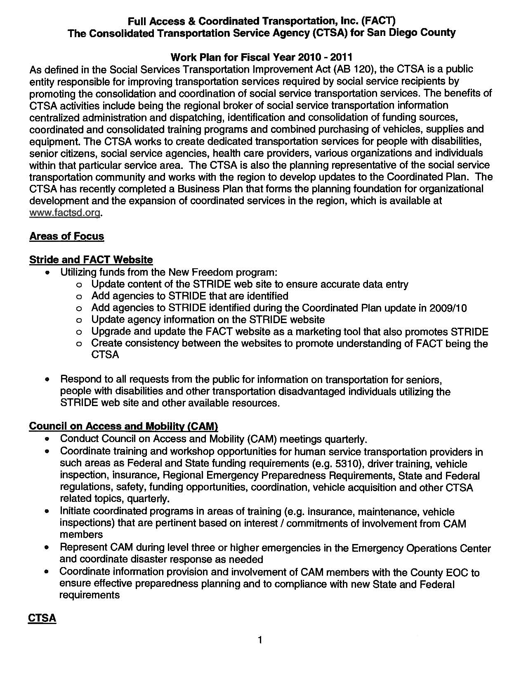
1. CTSA Work Plan

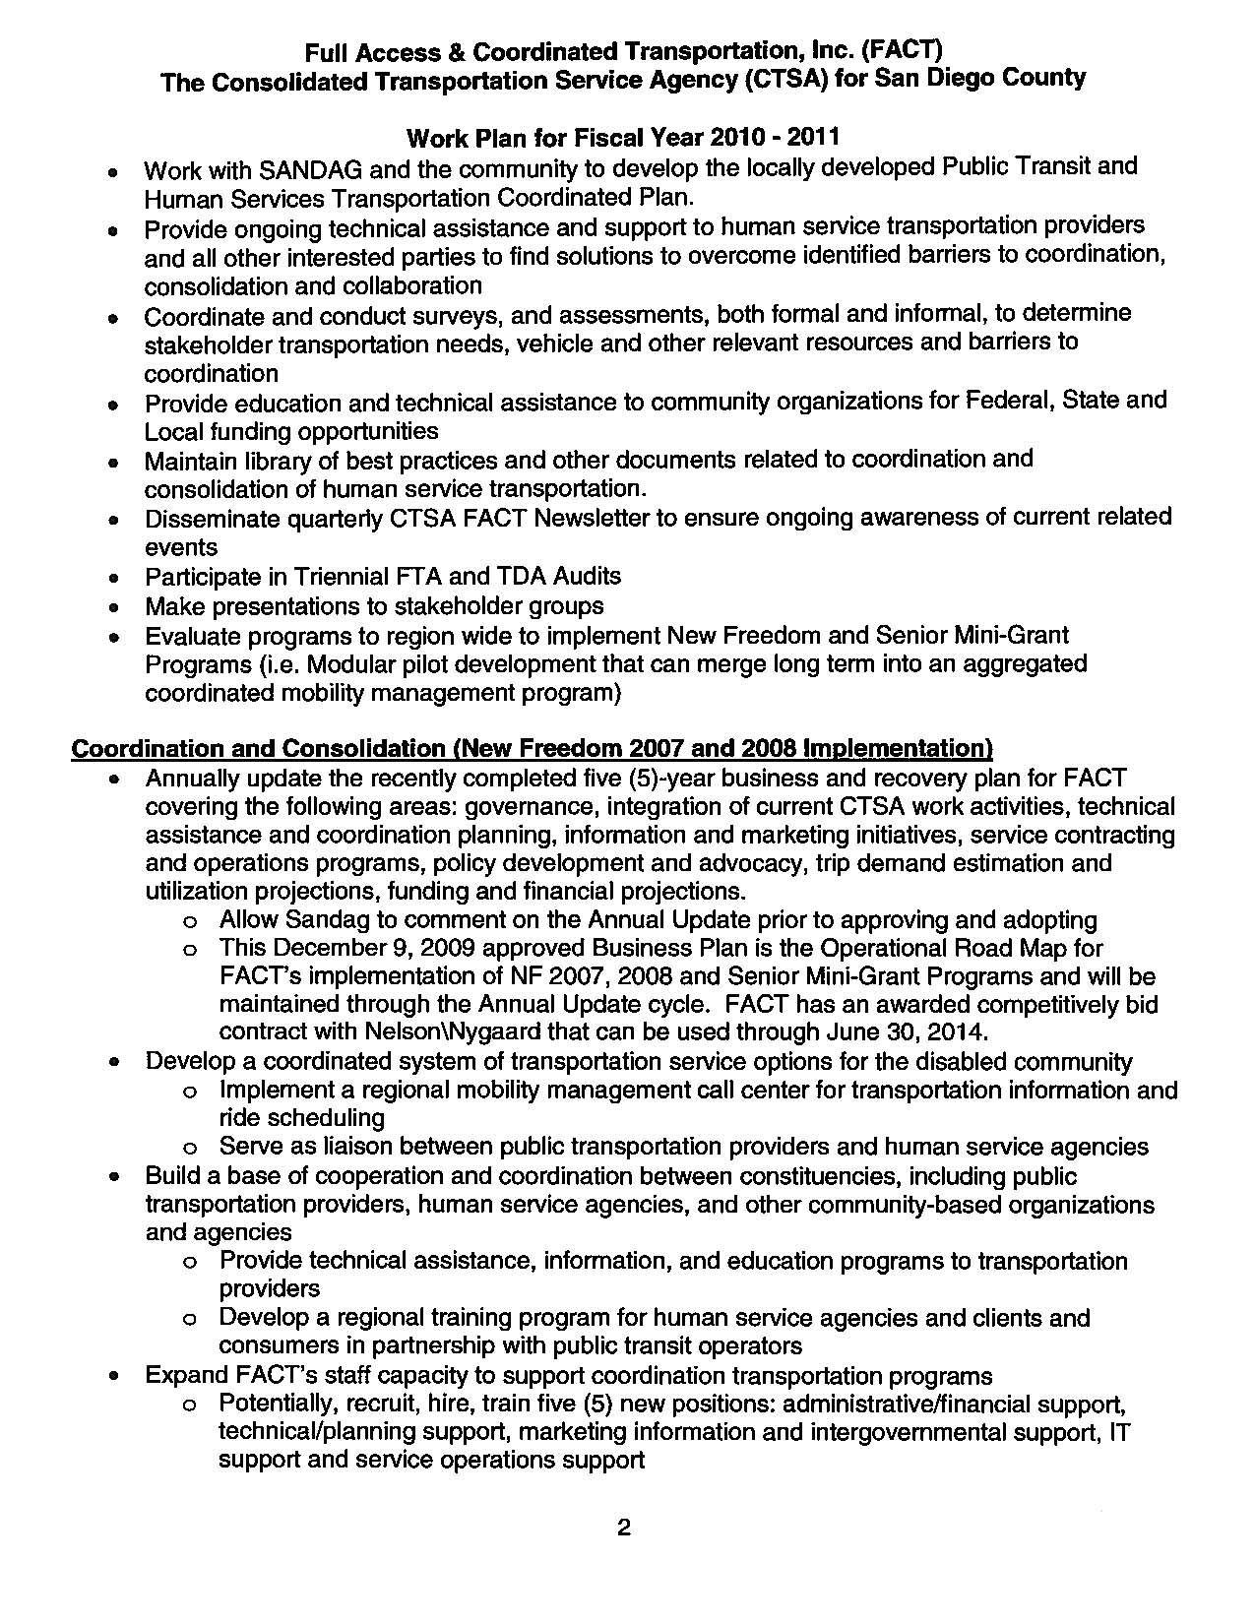

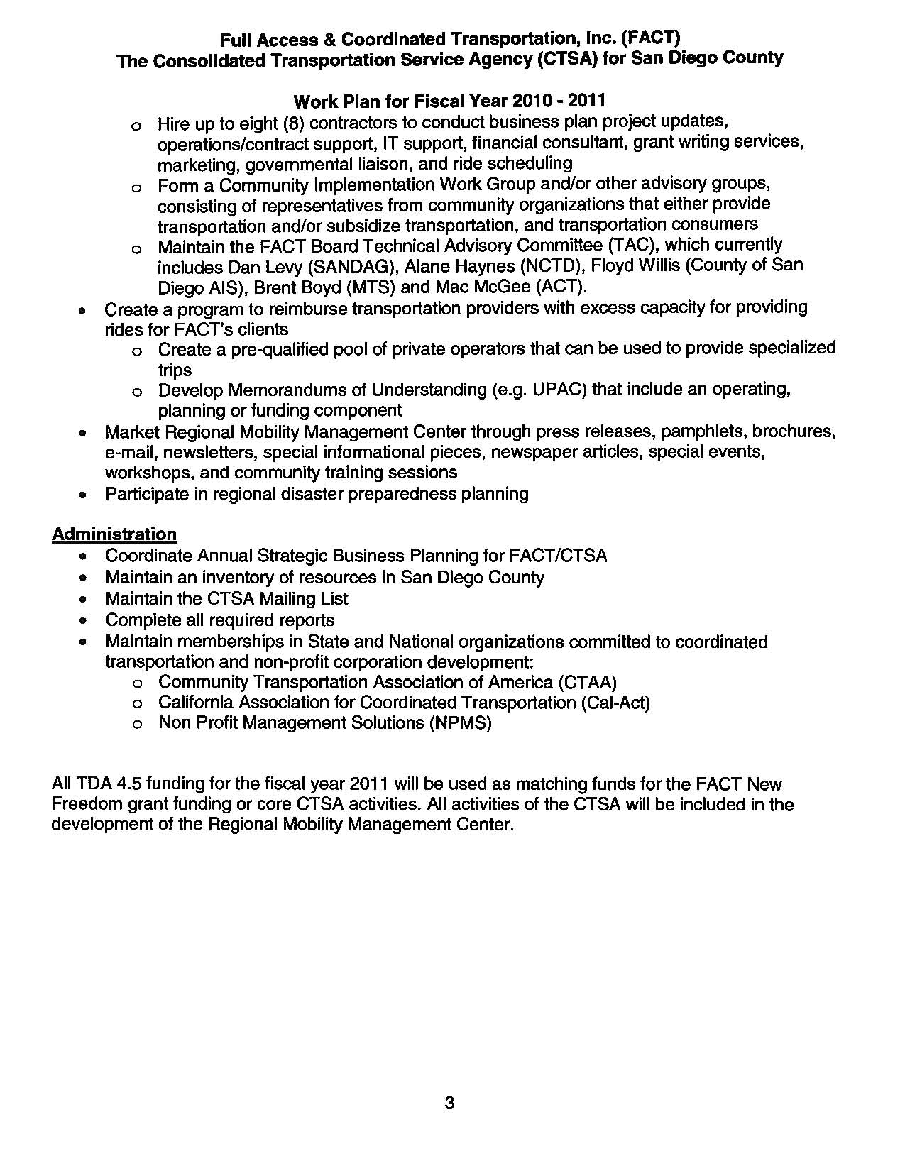

2. Service Providers

24-7 Taxicab
AAA Transport, Inc.
Ability Center Rental Vans for Disabled
All Congregations Together
Alpha Project Senior Transportation Program
Alpha Project Uptown Program
At Your Home Familycare Transportation
Care 4U Mobility Non-Emergency Transportation
Care-A-Van
Carlsbad West Taxi Company
CCSA - Clairemont Service Center
CCSA - Joyce Snyder Center
Comfort Coach Transport, Inc.
Community Mobile Connections
Courtesy Cab
Daily Patient Transport, Inc.
Fallbrook Taxi
FISH Service Volunteer Driver Program
Full Access & Coordinated Transportation, (FACT)
Fun, Love & Care Transportation
Golden Health Transportation
Heritage Senior CareTransportation/Escort Program
Hostelling International - San Diego - Downtown
Hostelling International - San Diego - Point Loma
Joan's Journey Senior Transportation Program
Love 2 Live Care Services
Manalo Transportation Service
Marilyn Cunningham
MTS San Diego Trolley
NCTD Travel Training Services
No Vacancy Transportation Program
Rancho Bernardo Commun. Pres. Church Transport.
Reliable Transportation for Medical Appointments
Ride With Emilio
RIDELINK
Rides by Right At Home
Rock Church Elderly Ministry
SD COMMUTE (MTS)
SD COMMUTE (NCTD)
Sol Transportation, Inc.
Solana Beach Presbyterian Church Transportation
Super Shuttle
Tender Nursing & Home Care Transportation Service
TLC Medical Transport
Transit Van Shuttle
Yellow Cab San Diego & North County
Transportation Services are OEnrolled in the Program
Adult Protective Serv Adult Day Healthcare Program
Aging & Independence Services
Alliance for African Assistance Transportation
Alpha Project Outreach & Transportation Program
ALS AssociationTransportation
American Cancer Society's Road to Recovery
AmeriCare ADHC Transportation
Blind Comm. Center Transportation for Craft Class
Boys & Girls Club Chula Vista Transp. Program
Boys & Girls Club North County Transportation
Boys & Girls Club of San Dieguito
Boys & Girls Club San Marcos Transportation
Braille Institute Student Transportation Program
Cal-Diego Paralyzed Veterans Assoc. Transportation
Camp Pendleton Y-Shuttle
Carlsbad Senior Center Transportation Services
Casa de Salud Center
CET - San Ysidro Student Shuttle Bus
Charles Cheneweth Foundation ADHC Transportation
Charles Cheneweth Foundation Community Access
City Link Foundation
City of San Marcos Senior Center
City of San Marcos Taxi Voucher Program
City of Vista Senior Nutrition Program
College Ave. Nutrition Transportation
Disabled American Veterans
DMCC Dial A Ride
DMCC Shuttle Bus
DMCC Volunteer Drivers
Don Allen Parentcare Family Recovery Center
ElderHelp of San Diego Volunteer Drivers
Employment and Community Options
Encinitas Senior Center Nutrition Lunch Program
Escondido Joslyn Ctr Nutrition Transportation Prog
Fallbrook Senior Center Nutrition Program Transp.
In Home Care Quality Services
Int. Rescue Committee - First Things First Program
International Rescue Committee Transportation
ITN San Diego
Kimball Senior Center
La Maestra Family Clinic Transportation
Lake San Marcos Kiwanis Club CARe Drive Program
Lenora's Homecare Services Transportation
LIFT Transportation, ADA Paratransit Service
LiveWell Transportation Program
LivHome Client Transportation Program
LSS Senior Companion Program
MAAC Project Head Start Program
Mountain Health Transportation Prog. Campo Clinic
Mountain Shadows Commun. Homes Transportation Prog
MTS Access Suburban Route
MTS Access Urban Route
National MS Society Pacific South Coast Chapter
National Runaway Home Free Program
Neighborhood House ADHC Transportation
Neighborhood House Senior Center Transportation
New Entra Casa Transportation
Noah Homes Transportation
North County Inland Senior Center
Oceanside - Solutions for Seniors on the Go
Oceanside Senior Nutrition Transportation
On The Go
Out & About Encinitas
Out & About Escondido
Out & About Peninsula
Out & About Vista Mileage Reimbursement Program
Out & About Vista Senior Shuttle
Paradise Senior Health Center
Paradise Valley Hospital Guest Transportation Serv
Poway Adult Day Health Care
Poway Senior Center Transportation
Presbyterian Urban Ministries
Project CARE Taxi Voucher Program, San Marcos
Project CARE Vista, Friendly Visitor Program
Redwood Club Transportation
Redwood Elderlink Adult Day Healthcare
Rides4Neighbors/Discount Taxi Program
Ryan White CARE Act
S.D.Y.C.S. Storefront Teen Shelter
Samahan Senior Center
San Diego American Indian Health Center Outreach
San Diego Center For The Blind-Transportation
San Diego Healthcare for the Homeless Project
San Diego Regional Center ADA Paratransit Tickets
San Diego Regional Center Bus Pass Program
San Diego Regional Center Contract Services
San Diego Regional Center Family Reimbursement
Scripps La Jolla Mobile Shuttle
Scripps Mercy Shuttle
Senior Healthcare Serivces
Senior Service Council of Escondido
Sharp Health Care Transportation
Sharp Senior Health Ctr Downtown Patient Van Serv.
Solana Beach Dial-A-Ride
St. Clare's Home
St. Madeleine Sophie's Center Day Programs
The Care Van, Fallbrook
Travelers Aid Soc. - Family Reunification Program
Travelers Aid Society of San Diego
Tri-City Patient Transport Express
University City Senior Center Transportation
UPLIFT Senior Partners Plus
UPLIFT Triple Cross
Uptown Faith Community Service Center
VA Transportation Network Patient Travel
Vista Community Clinic Transportation

2010-2014 Coordinated Plan. Chapter 7 “Needs Assessment”
Appendix O — Regional Transit and Social Services Gaps, Coordinated Plan, p. O-1—O.30

