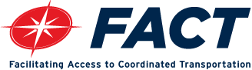

AGENDA

2022 ANNUAL BOARD of DIRECTORS MEETING
December 7, 2022
San Diego History Center, Balboa Park

Networking, Coffee - 8:30AM

Call to Order 9:30AM

WELCOMING REMARKS

PUBLIC COMMENT

DRIVING ACCESS & INNOVATION
PRESENTATION - FY 2022 PERFORMANCE & FINANCIAL AUDIT REPORTS

GUEST SPEAKER
Ms. Veronica Vanterpool

GUEST SPEAKER
Mr. Matthew O. Tucker

GUEST SPEAKER
Ms. Sharon Cooney

GUEST SPEAKER
Mr. Hasan Ikhrata

KEYNOTE ADDRESS
Hon. Raul A. Campillo

AWARDS
VENDOR OF THE YEAR
SDMED Inc.

2022 NORINE SIGAFOOSE PARTNER OF THE YEAR
Hon. Bill Sandke

CLOSING REMARKS

ADJOURNMENT

